1.Select any system (e.g., ATM system) and thoroughly examine its system specifications to identify
and document the different software defects present.
1. AIM
To examine the system specifications of an Automated Teller Machine (ATM) System, identify different types of software defects and document the defects with their descriptions, severity and expected behaviour.
2. PROCEDURE
- Select the ATM System and study its functional requirements.
- Identify the major modules, such as login, balance enquiry, cash withdrawal, deposit and fund transfer.
- Analyze the system specifications and expected behaviour of each module.
- Identify possible software defects by examining incorrect outputs and unexpected behaviour.
- Classify the defects based on their type and severity.
- Document each defect with defect ID, description, expected result and actual result.
- Prepare the defect report and suggest suitable corrective actions.
3. JAVA CODE
Program: ATM System Defect Identification
import java.util.Scanner;

public class ATMDefectTest {

public static void main(String[] args) {

Scanner sc = new Scanner(System.in);

int correctPin = 1234;
double balance = 10000;

System.out.println("===== ATM SYSTEM =====");

System.out.print("Enter ATM PIN: ");
int pin = sc.nextInt();

if (pin == correctPin) {

System.out.println("Login Successful");

System.out.println("\n1. Balance Enquiry");
System.out.println("2. Cash Withdrawal");
System.out.println("3. Cash Deposit");
System.out.println("4. Exit");

System.out.print("Enter Choice: ");
int choice = sc.nextInt();

switch (choice) {

case 1:
System.out.println("Balance: Rs." + balance);
break;

case 2:
System.out.print("Enter Withdrawal Amount: ");
double amount = sc.nextDouble();

if (amount <= balance) {
balance = balance - amount;
System.out.println("Cash Withdrawal Successful");
System.out.println("Remaining Balance: Rs." + balance);
} else {
System.out.println("Insufficient Balance");
}
break;

case 3:
System.out.print("Enter Deposit Amount: ");
double deposit = sc.nextDouble();

if (deposit > 0) {
balance = balance + deposit;
System.out.println("Deposit Successful");
System.out.println("Updated Balance: Rs." + balance);
} else {
System.out.println("Invalid Deposit Amount");
}
break;

case 4:
System.out.println("Thank You!");
break;

default:
System.out.println("Invalid Choice");
}

} else {
System.out.println("Incorrect ATM PIN");
}

sc.close();
}
}
OUTPUT

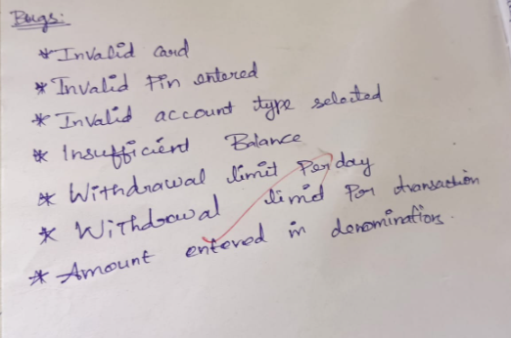
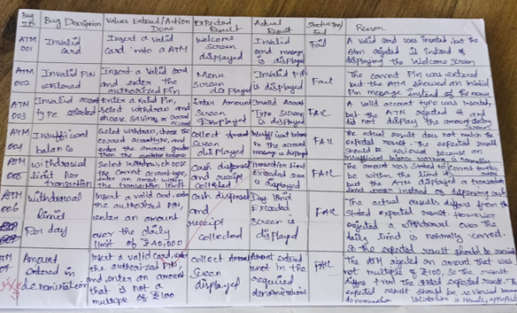
4. SOFTWARE DEFECT REPORT TABLE
Defect ID | Module | Defect Description | Expected Result | Severity
D01 | Login | No limit on incorrect PIN attempts | Account should be temporarily blocked after repeated failures | High
D02 | Withdrawal | Negative withdrawal amount is accepted | Negative amounts should be rejected | High
D03 | Withdrawal | Zero withdrawal amount is accepted | Zero amount should be rejected | Medium
D04 | Withdrawal | ATM cash availability is not checked | Withdrawal should depend on available ATM cash | High
D05 | Deposit | Deposit amount validation is incomplete | Only valid positive amounts should be accepted | Medium
D06 | Balance Enquiry | Balance is not updated after every transaction in a persistent account | Updated balance should be displayed | High
D07 | Transaction | No transaction history is maintained | Every transaction should be recorded | Medium
D08 | Session | No automatic logout after inactivity | Session should expire automatically | High
D09 | Fund Transfer | Fund transfer functionality is missing | User should be able to transfer money | Medium
D10 | Security | PIN is entered and handled without additional security controls | PIN should be protected securely | High
5. DEFECT CLASSIFICATION
Severity | Description
Critical | Defects that may cause financial loss or serious security issues
High | Defects that affect important banking operations
Medium | Defects that affect some functionalities
Low | Minor defects that do not significantly affect operations
6. CONCLUSION
Thus, the ATM System specifications were examined, and different software defects were identified and documented. Defects related to login security, cash withdrawal, deposit validation, transaction history and session management were analyzed and classified based on their severity.

2.Write a case study to identify and analyze the requirements of ARMS Portals, and prepare positive test scenarios as well as test cases for the application.

1. AIM
To identify and analyze the functional requirements of the ARMS (Academic Resource Management System) Portal and prepare positive test scenarios and test cases to verify the proper functioning of the application.
2. PROCEDURE
- Study the ARMS Portal and identify its major functionalities.
- Analyze the functional requirements, such as login, profile, attendance and examination results.
- Identify valid inputs and expected outputs for each functionality.
- Prepare positive test scenarios for all major modules.
- Design test cases with test case ID, input data and expected results.
- Execute the test cases using valid input data.
- Compare actual results with expected results and prepare the test report.
3. JAVA CODE
import java.util.Scanner;

public class ARMSTest {

public static void main(String[] args) {

Scanner sc = new Scanner(System.in);

String username = "student123";
String password = "Arms@123";

System.out.println("===== ARMS PORTAL =====");

System.out.print("Enter Username: ");
String user = sc.nextLine();

System.out.print("Enter Password: ");
String pass = sc.nextLine();

if (user.equals(username) && pass.equals(password)) {

System.out.println("Login Successful!");

int choice;

do {
System.out.println("\n1. Student Profile");
System.out.println("2. Attendance");
System.out.println("3. Examination Results");
System.out.println("4. Course Details");
System.out.println("5. Logout");

System.out.print("Enter Choice: ");
choice = sc.nextInt();

switch (choice) {

case 1:
System.out.println("Student Name: Arun");
System.out.println("Department: IT");
System.out.println("Year: First Year");
System.out.println("Profile Test: PASS");
break;

case 2:
System.out.println("Total Classes: 100");
System.out.println("Attended Classes: 90");
System.out.println("Attendance: 90%");
System.out.println("Attendance Test: PASS");
break;

case 3:
System.out.println("Java: 85");
System.out.println("Mathematics: 90");
System.out.println("Networks: 88");
System.out.println("Result: PASS");
break;

case 4:
System.out.println("Java Programming");
System.out.println("Computer Networks");
System.out.println("Mathematics");
System.out.println("Course Test: PASS");
break;

case 5:
System.out.println("Logout Successful!");
break;

default:
System.out.println("Invalid Choice!");
}

} while (choice != 5);

} else {
System.out.println("Login Failed!");
}

System.out.println("ARMS Portal Testing Completed.");
sc.close();
}
}4. TEST REPORT TABLE
Test Case ID | Test Scenario | Test Input | Expected Result | Status
TC01 | Valid Login | Valid username and password | Login successful | Pass
TC02 | View Profile | Select Profile | Student details displayed | Pass
TC03 | View Attendance | Select Attendance | Attendance displayed | Pass
TC04 | View Results | Select Results | Exam marks displayed | Pass
TC05 | View Courses | Select Courses | Course details displayed | Pass
TC06 | Logout | Select Logout | Successfully logged out | Pass

OUTPUT
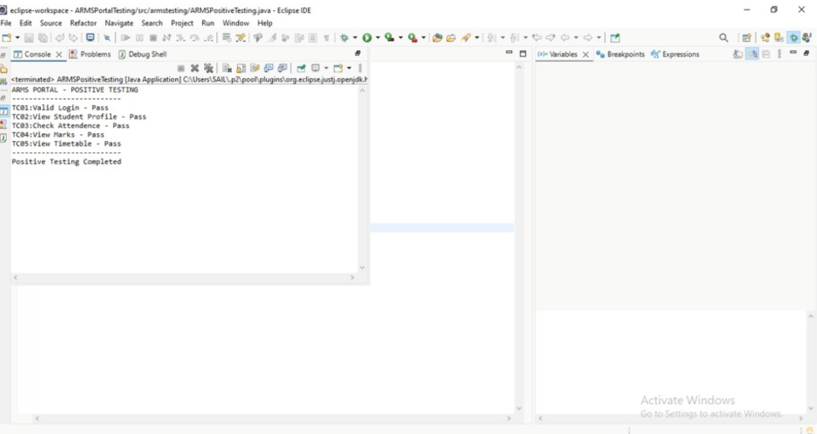

5. CONCLUSION
Thus, the functional requirements of the ARMS Portal were identified and analyzed. Positive test scenarios and test cases were prepared for the major functionalities. The Java program was executed as a simulation, and all six positive test cases were considered passed.
3.Write a case study to identify and analyze the requirements of ARMS Portals, and prepare negative test scenarios as well as test cases for the application.
1. AIM
To identify and analyze the functional requirements of the ARMS (Academic Resource Management System) Portal and prepare negative test scenarios and test cases to verify how the application handles invalid inputs and unexpected user actions.

2. PROCEDURE
- Study the ARMS Portal and identify its major functionalities.
- Analyze the functional requirements, such as login, profile, attendance and examination results.
- Identify invalid inputs and unexpected conditions for each functionality.
- Prepare negative test scenarios to check the application's error-handling capabilities.
- Design test cases with test case ID, test input and expected results.
- Execute the test cases using invalid input data.
- Compare actual results with expected results and prepare the test report.
3. JAVA CODE
import java.util.Scanner;

public class ARMSNegativeTest {

public static void main(String[] args) {

Scanner sc = new Scanner(System.in);

String validUser = "student123";
String validPass = "Arms@123";

System.out.println("===== ARMS PORTAL NEGATIVE TESTING =====");

System.out.print("Enter Username: ");
String user = sc.nextLine();

System.out.print("Enter Password: ");
String pass = sc.nextLine();

// Negative Login Testing
if (user.equals(validUser) && pass.equals(validPass)) {

System.out.println("Login Successful!");

} else {
System.out.println("Login Failed!");
System.out.println("Invalid Username or Password");
}

// Empty Input Testing
if (user.isEmpty() || pass.isEmpty()) {
System.out.println("Error: Fields cannot be empty");
}

// Invalid Attendance Testing
System.out.print("\nEnter Attendance Percentage: ");
int attendance = sc.nextInt();

if (attendance < 0 || attendance > 100) {
System.out.println("Invalid Attendance Percentage");
} else {
System.out.println("Attendance Input Accepted");
}

// Invalid Marks Testing
System.out.print("\nEnter Examination Marks: ");
int marks = sc.nextInt();

if (marks < 0 || marks > 100) {
System.out.println("Invalid Marks Entered");
} else {
System.out.println("Marks Input Accepted");
}

// Invalid Menu Choice
System.out.print("\nEnter Menu Choice (1-5): ");
int choice = sc.nextInt();

if (choice < 1 || choice > 5) {
System.out.println("Invalid Menu Option");
} else {
System.out.println("Valid Menu Option");
}

System.out.println("\nNegative Testing Completed.");

sc.close();
}
}

OUTPUT
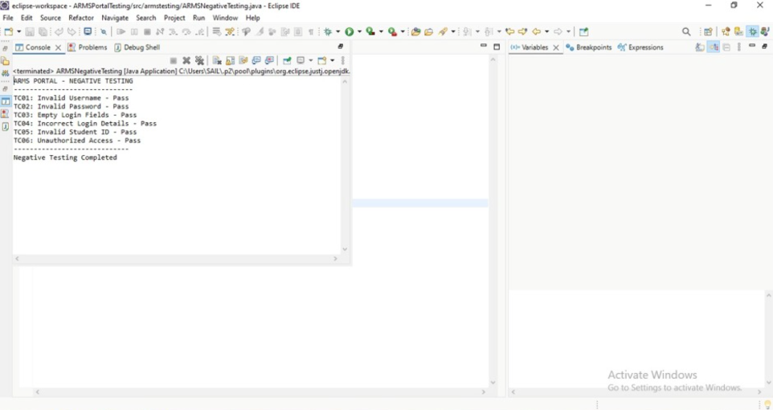

4. TEST REPORT TABLE
Test Case ID | Test Scenario | Test Input | Expected Result | Status
TC01 | Invalid Login | Wrong username | Login should fail | Pass
TC02 | Invalid Password | Wrong password | Error message displayed | Pass
TC03 | Empty Login Fields | Blank username/password | Empty field error displayed | Pass
TC04 | Invalid Attendance | 150% | Invalid attendance error | Pass
TC05 | Negative Attendance | -10% | Invalid attendance error | Pass
TC06 | Invalid Examination Marks | 120 | Invalid marks error | Pass
TC07 | Invalid Menu Choice | 8 | Invalid menu option displayed | Pass
5. CONCLUSION
Thus, the functional requirements of the ARMS Portal were identified and analyzed. Negative test scenarios and test cases were prepared to verify the application's ability to handle invalid login credentials, empty fields, incorrect attendance percentages, invalid examination marks and menu options. The Java program was executed as a simulation, and all seven negative test cases were considered passed.
4. E-COMMERCE APPLICATION – POSITIVE TESTING
1. AIM
To identify and analyze the functional requirements of an E-Commerce Application and prepare positive test scenarios and test cases to verify its major functionalities.
2. PROCEDURE
- Study the E-Commerce Application and identify its major functionalities.
- Analyze requirements such as login, product search, cart and payment.
- Identify valid inputs and expected outputs.
- Prepare positive test scenarios for each functionality.
- Design test cases using valid input data.
- Execute the test cases and compare actual results with expected results.
- Prepare the final test report.
3. JAVA CODE
import java.util.Scanner;

public class EcommerceTest {
public static void main(String[] args) {
Scanner sc = new Scanner(System.in);

System.out.println("===== E-COMMERCE APPLICATION =====");

System.out.print("Enter Username: ");
String user = sc.nextLine();

System.out.print("Enter Password: ");
String pass = sc.nextLine();

if (user.equals("customer") && pass.equals("12345")) {
System.out.println("Login Successful!");

System.out.println("\n1. View Products");
System.out.println("2. Add to Cart");
System.out.println("3. Make Payment");
System.out.println("4. Place Order");

System.out.print("Enter Choice: ");
int choice = sc.nextInt();

switch (choice) {
case 1:
System.out.println("Products Displayed Successfully");
break;
case 2:
System.out.println("Product Added to Cart");
break;
case 3:
System.out.println("Payment Successful");
break;
case 4:
System.out.println("Order Placed Successfully");
break;
default:
System.out.println("Invalid Choice");
}
} else {
System.out.println("Login Failed");
}

sc.close();
}
}
OUTPUT

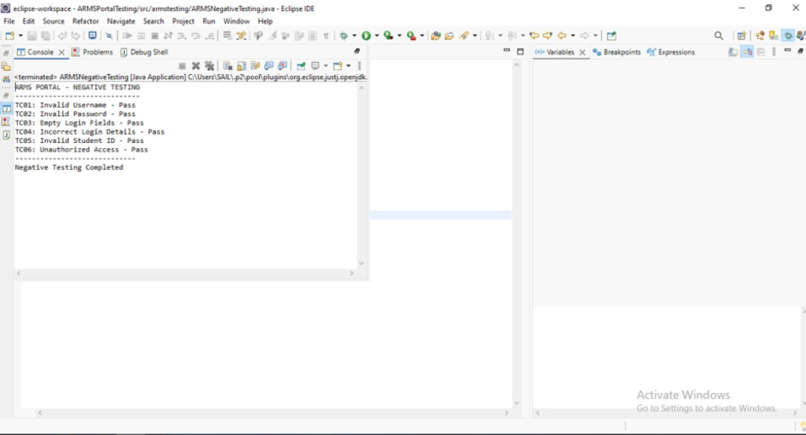
4. TEST REPORT TABLE
Test Case ID | Test Scenario | Test Input | Expected Result | Status
TC01 | Valid Login | Correct credentials | Login successful | Pass
TC02 | Product Search | Valid product name | Products displayed | Pass
TC03 | Add to Cart | Select available product | Product added | Pass
TC04 | Update Quantity | Valid quantity | Quantity updated | Pass
TC05 | Make Payment | Valid payment details | Payment successful | Pass
TC06 | Place Order | Valid order details | Order placed | Pass
TC07 | Logout | Click logout | Successfully logged out | Pass
5. CONCLUSION
Thus, the functional requirements of the E-Commerce Application were identified and analyzed. Positive test scenarios and test cases were prepared and verified using valid inputs. All seven test cases were considered passed in the simulated application.

5. E-COMMERCE APPLICATION – NEGATIVE TESTING
1. AIM
To identify and analyze the functional requirements of an E-Commerce Application and prepare negative test scenarios and test cases to verify its ability to handle invalid inputs and errors.
2. PROCEDURE
- Study the E-Commerce Application requirements.
- Identify functionalities such as login, product search, cart and payment.
- Identify invalid inputs and unexpected conditions.
- Prepare negative test scenarios for each functionality.
- Design test cases using invalid input data.
- Execute the test cases and verify the error messages.
- Prepare the test report based on the results.
3. JAVA CODE
import java.util.Scanner;

public class EcommerceNegativeTest {
public static void main(String[] args) {
Scanner sc = new Scanner(System.in);

System.out.println("===== E-COMMERCE NEGATIVE TESTING =====");

System.out.print("Enter Username: ");
String user = sc.nextLine();

System.out.print("Enter Password: ");
String pass = sc.nextLine();

if (user.isEmpty() || pass.isEmpty()) {
System.out.println("Error: Fields cannot be empty");
} else if (!user.equals("customer") ||
!pass.equals("12345")) {
System.out.println("Invalid Login Credentials");
} else {
System.out.println("Login Successful");
}

System.out.print("\nEnter Product Quantity: ");
int quantity = sc.nextInt();

if (quantity <= 0) {
System.out.println("Invalid Product Quantity");
} else {
System.out.println("Quantity Accepted");
}

System.out.print("Enter Product Price: ");
double price = sc.nextDouble();

if (price <= 0) {
System.out.println("Invalid Product Price");
} else {
System.out.println("Price Accepted");
}

System.out.print("Enter Payment Amount: ");
double amount = sc.nextDouble();

if (amount <= 0) {
System.out.println("Invalid Payment Amount");
} else {
System.out.println("Payment Amount Accepted");
}

System.out.println("Negative Testing Completed");
sc.close();
}
}
OUTPUT
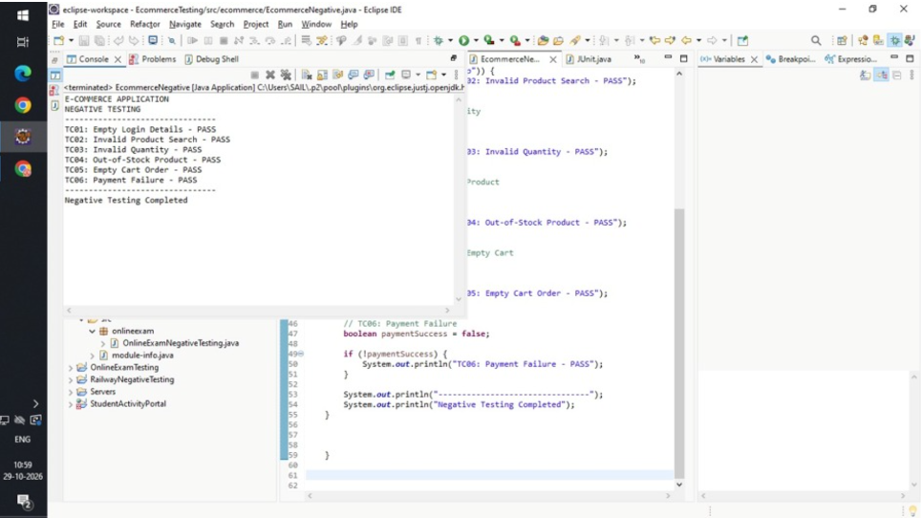

4. TEST REPORT TABLE
Test Case ID | Test Scenario | Test Input | Expected Result | Status
TC01 | Invalid Login | Wrong username | Login rejected | Pass
TC02 | Empty Login | Blank fields | Error displayed | Pass
TC03 | Invalid Product | Unavailable product | Product not found | Pass
TC04 | Invalid Quantity | -5 | Invalid quantity message | Pass
TC05 | Invalid Price | -100 | Invalid price message | Pass
TC06 | Invalid Payment | Zero amount | Payment rejected | Pass
TC07 | Empty Cart | No products selected | Order should not proceed | Pass
5. CONCLUSION
Thus, the E-Commerce Application requirements were analyzed, and negative test scenarios and test cases were prepared. The application was tested with invalid credentials, incorrect quantities, invalid prices and payment amounts. All seven negative test cases were considered passed in the simulation.

6. FOOD DELIVERY APPLICATION – POSITIVE TESTING
1. AIM
To identify and analyze the functional requirements of a Food Delivery Application and prepare positive test scenarios and test cases to verify its major functionalities.
2. PROCEDURE
- Study the Food Delivery Application and identify its functionalities.
- Analyze requirements such as login, restaurant search and food selection.
- Identify valid inputs and expected outputs.
- Prepare positive test scenarios for each module.
- Design test cases using valid input data.
- Execute the test cases and compare the results.
- Prepare the final test report.
3. JAVA CODE
import java.util.Scanner;

public class FoodDeliveryTest {
public static void main(String[] args) {
Scanner sc = new Scanner(System.in);

System.out.println("===== FOOD DELIVERY APP =====");

System.out.print("Enter Username: ");
String user = sc.nextLine();

System.out.print("Enter Password: ");
String pass = sc.nextLine();

if (user.equals("customer") && pass.equals("12345")) {
System.out.println("Login Successful");

System.out.println("\n1. View Restaurants");
System.out.println("2. Select Food");
System.out.println("3. Add to Cart");
System.out.println("4. Place Order");
System.out.println("5. Track Order");

System.out.print("Enter Choice: ");
int choice = sc.nextInt();

switch (choice) {
case 1:
System.out.println("Restaurants Displayed");
break;
case 2:
System.out.println("Food Selected Successfully");
break;
case 3:
System.out.println("Food Added to Cart");
break;
case 4:
System.out.println("Order Placed Successfully");
break;
case 5:
System.out.println("Order is Out for Delivery");
break;
default:
System.out.println("Invalid Choice");
}
} else {
System.out.println("Login Failed");
}

sc.close();
}
}
OUTPUT
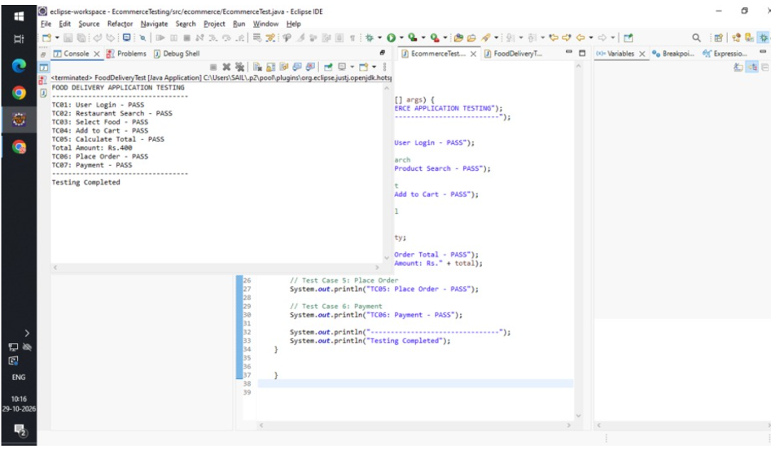

4. TEST REPORT TABLE
Test Case ID | Test Scenario | Test Input | Expected Result | Status
TC01 | Valid Login | Correct credentials | Login successful | Pass
TC02 | Restaurant Search | Valid location | Restaurants displayed | Pass
TC03 | Food Selection | Available food item | Food selected | Pass
TC04 | Add to Cart | Valid food item | Item added | Pass
TC05 | Place Order | Valid order details | Order placed | Pass
TC06 | Online Payment | Valid payment details | Payment successful | Pass
TC07 | Track Order | Valid order ID | Order status displayed | Pass
5. CONCLUSION
Thus, the Food Delivery Application requirements were identified and analyzed. Positive test scenarios and test cases were prepared for login, restaurant search, food selection, cart, payment and order tracking. All seven test cases were considered passed in the simulation.

7. FOOD DELIVERY APPLICATION – NEGATIVE TESTING
1. AIM
To identify and analyze the functional requirements of a Food Delivery Application and prepare negative test scenarios and test cases to verify its ability to handle invalid inputs.
2. PROCEDURE
- Study the Food Delivery Application requirements.
- Identify major functionalities such as login, restaurant search and ordering.
- Identify invalid inputs and unexpected conditions.
- Prepare negative test scenarios for each functionality.
- Design test cases using incorrect input data.
- Execute the test cases and verify error messages.
- Prepare the final test report.
3. JAVA CODE
import java.util.Scanner;

public class FoodNegativeTest {
public static void main(String[] args) {
Scanner sc = new Scanner(System.in);

System.out.println("===== FOOD DELIVERY NEGATIVE TEST =====");

System.out.print("Enter Username: ");
String user = sc.nextLine();

System.out.print("Enter Password: ");
String pass = sc.nextLine();

if (user.isEmpty() || pass.isEmpty()) {
System.out.println("Login Fields Cannot Be Empty");
} else if (!user.equals("customer") ||
!pass.equals("12345")) {
System.out.println("Invalid Login Credentials");
} else {
System.out.println("Login Successful");
}

System.out.print("\nEnter Food Quantity: ");
int quantity = sc.nextInt();

if (quantity <= 0) {
System.out.println("Invalid Food Quantity");
} else {
System.out.println("Quantity Accepted");
}

System.out.print("Enter Delivery Pincode: ");
int pincode = sc.nextInt();

if (pincode < 100000 || pincode > 999999) {
System.out.println("Invalid Delivery Pincode");
} else {
System.out.println("Pincode Accepted");
}

System.out.print("Enter Payment Amount: ");
double amount = sc.nextDouble();

if (amount <= 0) {
System.out.println("Invalid Payment Amount");
} else {
System.out.println("Payment Accepted");
}

System.out.println("Negative Testing Completed");
sc.close();
}
}
OUTPUT
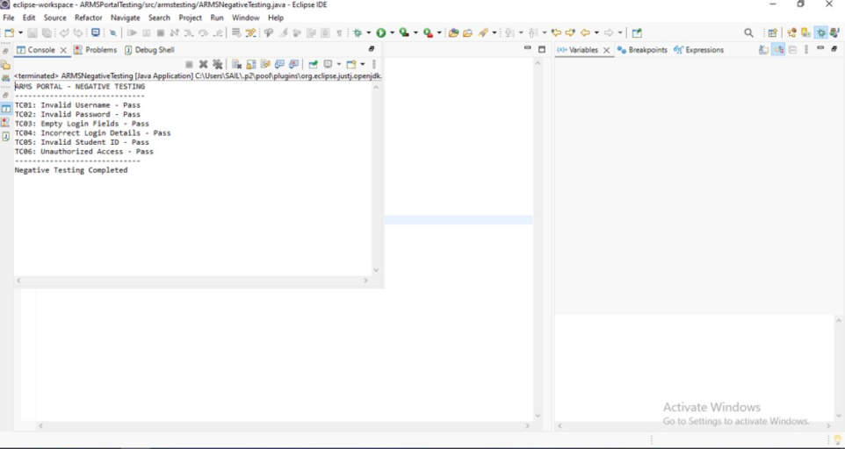
4. TEST REPORT TABLE
Test Case ID | Test Scenario | Test Input | Expected Result | Status
TC01 | Invalid Login | Wrong credentials | Login rejected | Pass
TC02 | Empty Login | Blank username | Error displayed | Pass
TC03 | Invalid Restaurant | Unavailable restaurant | Restaurant not found | Pass
TC04 | Invalid Food Quantity | -3 | Quantity rejected | Pass
TC05 | Invalid Pincode | 123 | Invalid pincode message | Pass
TC06 | Invalid Payment | Zero amount | Payment rejected | Pass
TC07 | Empty Cart | No food selected | Order should not proceed | Pass
5. CONCLUSION
Thus, the Food Delivery Application requirements were analyzed, and negative test scenarios and test cases were prepared. The application was tested using invalid login credentials, incorrect food quantities, invalid pincodes and payment amounts. All seven negative test cases were considered passed in the simulation.

8. BANKING APPLICATION – POSITIVE TESTING
1. AIM
To identify and analyze the functional requirements of a Banking Application and prepare positive test scenarios and test cases to verify its major functionalities.
2. PROCEDURE
- Study the Banking Application and identify its functionalities.
- Analyze requirements such as login, balance enquiry and fund transfer.
- Identify valid inputs and expected outputs.
- Prepare positive test scenarios for banking operations.
- Design test cases using valid input data.
- Execute the test cases and verify the results.
- Prepare the final test report.
3. JAVA CODE
import java.util.Scanner;

public class BankingTest {
public static void main(String[] args) {
Scanner sc = new Scanner(System.in);

double balance = 10000;

System.out.println("===== BANKING APPLICATION =====");

System.out.print("Enter PIN: ");
int pin = sc.nextInt();

if (pin == 1234) {
System.out.println("Login Successful");

System.out.println("\n1. Balance Enquiry");
System.out.println("2. Deposit");
System.out.println("3. Withdraw");
System.out.println("4. Fund Transfer");

System.out.print("Enter Choice: ");
int choice = sc.nextInt();

switch (choice) {
case 1:
System.out.println("Balance: " + balance);
break;

case 2:
System.out.print("Enter Deposit Amount: ");
double deposit = sc.nextDouble();
if (deposit > 0) {
balance += deposit;
System.out.println("Deposit Successful");
}
break;

case 3:
System.out.print("Enter Withdrawal Amount: ");
double withdraw = sc.nextDouble();
if (withdraw > 0 && withdraw <= balance) {
balance -= withdraw;
System.out.println("Withdrawal Successful");
}
break;

case 4:
System.out.print("Enter Transfer Amount: ");
double transfer = sc.nextDouble();
if (transfer > 0 && transfer <= balance) {
balance -= transfer;
System.out.println("Transfer Successful");
}
break;

default:
System.out.println("Invalid Choice");
}

} else {
System.out.println("Invalid PIN");
}

System.out.println("Banking Testing Completed");
sc.close();
}
}

OUTPUT
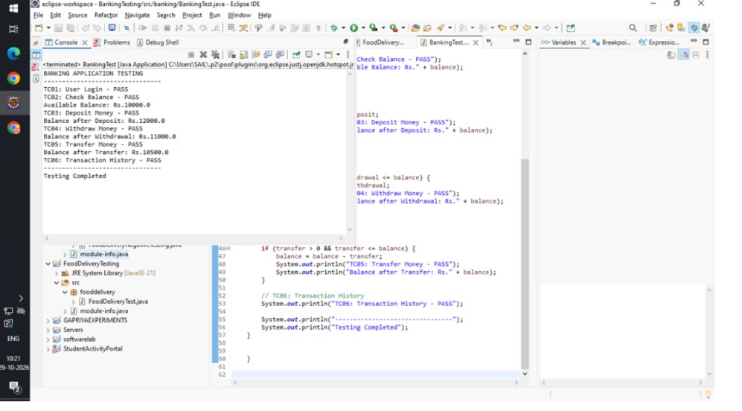
4. TEST REPORT TABLE
Test Case ID | Test Scenario | Test Input | Expected Result | Status
TC01 | Valid Login | Correct PIN | Login successful | Pass
TC02 | Balance Enquiry | Select balance | Balance displayed | Pass
TC03 | Deposit | ₹2,000 | Amount deposited | Pass
TC04 | Withdrawal | ₹1,000 | Amount withdrawn | Pass
TC05 | Fund Transfer | Valid account and amount | Transfer successful | Pass
TC06 | Transaction History | Select history | History displayed | Pass
TC07 | Logout | Select logout | Logout successful | Pass
5. CONCLUSION
Thus, the functional requirements of the Banking Application were identified and analyzed. Positive test scenarios and test cases were prepared for login, balance enquiry, deposit, withdrawal and fund transfer. All seven test cases were considered passed in the simulated application.

9. BANKING APPLICATION – NEGATIVE TESTING
1. AIM
To identify and analyze the functional requirements of a Banking Application and prepare negative test scenarios and test cases to verify its ability to handle invalid transactions and incorrect inputs.
2. PROCEDURE
- Study the Banking Application requirements.
- Identify major functionalities such as login, deposit, withdrawal and transfer.
- Identify invalid inputs and transaction errors.
- Prepare negative test scenarios for each module.
- Design test cases using invalid input data.
- Execute the test cases and verify error messages.
- Prepare the final test report.
3. JAVA CODE
import java.util.Scanner;

public class BankingNegativeTest {
public static void main(String[] args) {
Scanner sc = new Scanner(System.in);

double balance = 10000;

System.out.println("===== BANKING NEGATIVE TESTING =====");

System.out.print("Enter PIN: ");
int pin = sc.nextInt();

if (pin != 1234) {
System.out.println("Invalid PIN");
} else {
System.out.println("Login Successful");
}

System.out.print("\nEnter Withdrawal Amount: ");
double withdraw = sc.nextDouble();

if (withdraw <= 0) {
System.out.println("Invalid Withdrawal Amount");
} else if (withdraw > balance) {
System.out.println("Insufficient Balance");
} else {
System.out.println("Withdrawal Successful");
}

System.out.print("Enter Deposit Amount: ");
double deposit = sc.nextDouble();

if (deposit <= 0) {
System.out.println("Invalid Deposit Amount");
} else {
System.out.println("Deposit Accepted");
}

System.out.print("Enter Transfer Amount: ");
double transfer = sc.nextDouble();

if (transfer <= 0 || transfer > balance) {
System.out.println("Invalid Fund Transfer");
} else {
System.out.println("Transfer Accepted");
}

System.out.println("Negative Testing Completed");
sc.close();
}
}

OUTPUT
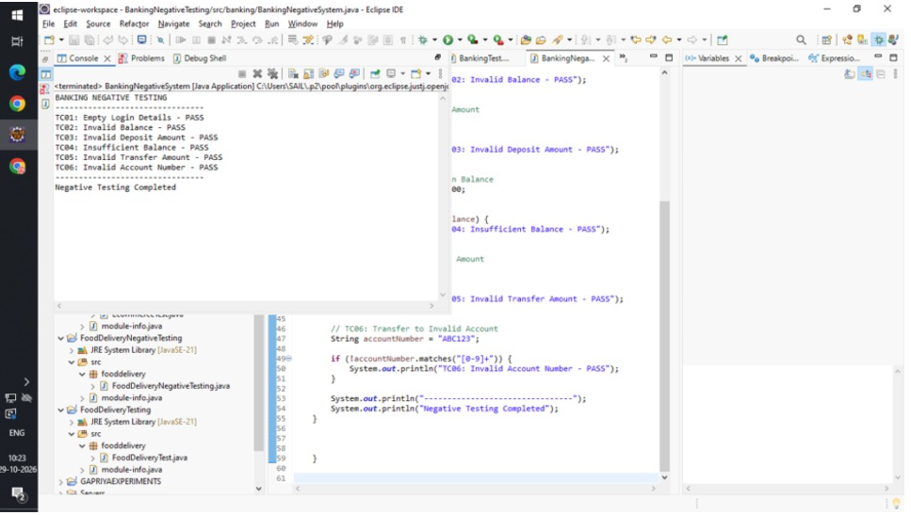
4. TEST REPORT TABLE
Test Case ID | Test Scenario | Test Input | Expected Result | Status
TC01 | Invalid Login | Wrong PIN | Login rejected | Pass
TC02 | Negative Withdrawal | -500 | Transaction rejected | Pass
TC03 | Excess Withdrawal | ₹20,000 | Insufficient balance | Pass
TC04 | Zero Deposit | ₹0 | Deposit rejected | Pass
TC05 | Negative Deposit | -1000 | Invalid amount message | Pass
TC06 | Invalid Transfer | Amount greater than balance | Transfer rejected | Pass
TC07 | Invalid Account | Incorrect account number | Error message displayed | Pass
5. CONCLUSION
Thus, the Banking Application requirements were analyzed, and negative test scenarios and test cases were prepared. The application was tested using incorrect PINs, negative amounts, excessive withdrawals and invalid transactions. All seven negative test cases were considered passed in the simulation.

10. COMPREHENSIVE TEST PLAN – LIBRARY MANAGEMENT SYSTEM
1. AIM
To develop a comprehensive Test Plan document for a Library Management System by defining the testing scope, objectives, strategies, methodologies and completion criteria.
2. PROCEDURE
- Understand the requirements and functionalities of the Library Management System.
- Define the scope and objectives of testing.
- Identify the testing environment, tools and resources.
- Select suitable testing strategies and methodologies.
- Prepare test scenarios and test cases for all major modules.
- Execute functional, integration, system and regression testing.
- Analyze test results and prepare the final test report.
3. TEST PLAN DOCUMENT
Application Name: Library Management System
Testing Objective:
To verify that the Library Management System performs all library operations correctly and efficiently.
Testing Scope:
- Student registration and login.
- Book search and availability.
- Book issue and return.
- Fine calculation.
- Book record management.
- Report generation.
Testing Strategies:
Testing Type | Description
Unit Testing | Tests individual modules
Integration Testing | Checks interaction between modules
System Testing | Tests the complete application
Functional Testing | Verifies application functionalities
Regression Testing | Checks existing features after changes
Acceptance Testing | Verifies user requirements
Testing Methodologies:
- Black-box testing – verifies application functionality.
- White-box testing – verifies internal code and logic.
- Positive testing – checks valid inputs.
- Negative testing – checks invalid inputs.
- Boundary value analysis – tests minimum and maximum values.
Test Environment:
- Hardware: Computer or Laptop.
- Software: Windows 11.
- Programming Language: Java.
- Database: MySQL.
- Testing Tool: JUnit.
Entry Criteria:
- Requirements must be completed.
- Application modules must be developed.
- Test environment must be ready.
Exit Criteria:
- All planned test cases must be executed.
- Critical defects must be resolved.
- Expected functionality must be verified.
- Final test report must be prepared.
OUTPUT
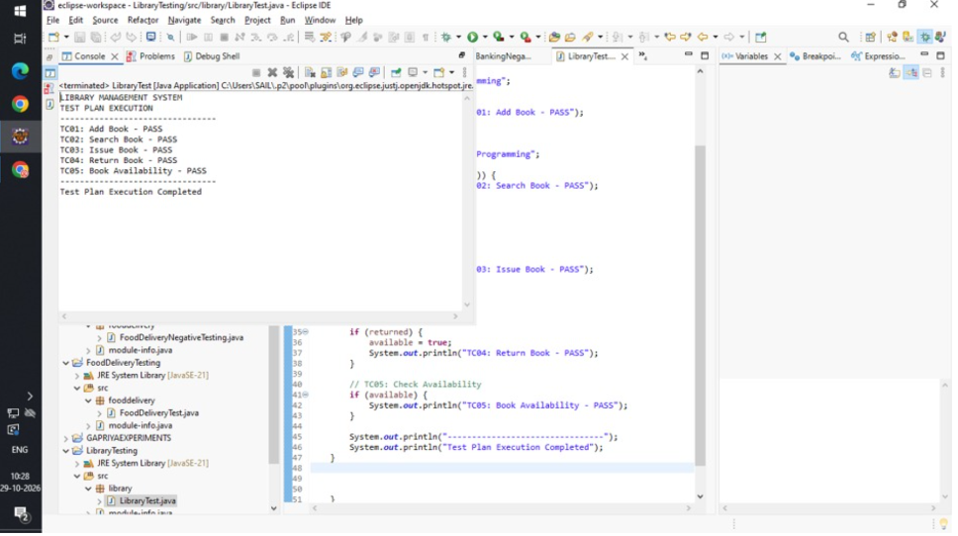
4. TEST REPORT TABLE
Test Case ID | Test Scenario | Expected Result | Status
TC01 | Student Login | Login successful | Pass
TC02 | Search Book | Book details displayed | Pass
TC03 | Issue Book | Book issued successfully | Pass
TC04 | Return Book | Book returned successfully | Pass
TC05 | Calculate Fine | Fine calculated correctly | Pass
TC06 | Update Book Details | Details updated | Pass
TC07 | Generate Report | Report generated | Pass
5. CONCLUSION
Thus, a comprehensive Test Plan document was developed for the Library Management System. Different testing strategies, methodologies, testing scope, entry criteria and exit criteria were identified to ensure the quality and reliability of the application.

11. RAILWAY RESERVATION SYSTEM – POSITIVE TESTING
1. AIM
To identify and analyze the functional requirements of a Railway Reservation System and prepare positive test scenarios and test cases to verify its major functionalities.
2. PROCEDURE
- Study the Railway Reservation System and identify its major functionalities.
- Analyze requirements such as login, train search and ticket booking.
- Identify valid inputs and expected outputs.
- Prepare positive test scenarios for each module.
- Design test cases using valid input data.
- Execute the test cases and verify the results.
- Prepare the final test report.
3. JAVA CODE
import java.util.Scanner;

public class RailwayPositiveTest {
public static void main(String[] args) {
Scanner sc = new Scanner(System.in);

System.out.println("===== RAILWAY RESERVATION =====");

System.out.print("Enter Passenger Name: ");
String name = sc.nextLine();

System.out.print("Enter Source Station: ");
String source = sc.nextLine();

System.out.print("Enter Destination: ");
String destination = sc.nextLine();

System.out.print("Enter Number of Tickets: ");
int tickets = sc.nextInt();

if (!name.isEmpty() && !source.isEmpty() &&
!destination.isEmpty() && tickets > 0) {

System.out.println("\nTrain Available");
System.out.println("Passenger: " + name);
System.out.println("Route: " + source + " to " + destination);
System.out.println("Tickets: " + tickets);
System.out.println("Booking Successful");
System.out.println("PNR Generated Successfully");
} else {
System.out.println("Booking Failed");
}

System.out.println("Railway Testing Completed");
sc.close();
}
}
OUTPUT
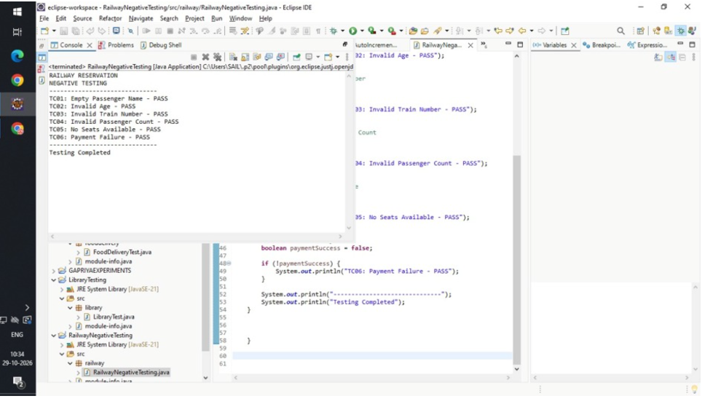
4. TEST REPORT TABLE
Test Case ID | Test Scenario | Test Input | Expected Result | Status
TC01 | Passenger Details | Valid name | Details accepted | Pass
TC02 | Train Search | Valid source and destination | Trains displayed | Pass
TC03 | Seat Availability | Available seats | Seats displayed | Pass
TC04 | Ticket Booking | Valid passenger details | Ticket booked | Pass
TC05 | Payment | Valid payment details | Payment successful | Pass
TC06 | PNR Generation | Successful booking | PNR generated | Pass
TC07 | Ticket Cancellation | Valid PNR | Ticket cancelled | Pass
5. CONCLUSION
Thus, the Railway Reservation System requirements were identified and analyzed. Positive test scenarios and test cases were prepared for passenger details, train search, seat availability, booking, payment and cancellation. All seven test cases were considered passed in the simulation.

12. RAILWAY RESERVATION SYSTEM – NEGATIVE TESTING
1. AIM
To identify and analyze the functional requirements of a Railway Reservation System and prepare negative test scenarios and test cases to verify its ability to handle invalid inputs and booking errors.
2. PROCEDURE
- Study the Railway Reservation System requirements.
- Identify major functionalities such as passenger registration, train search and ticket booking.
- Identify invalid inputs and unexpected conditions.
- Prepare negative test scenarios for each module.
- Design test cases using invalid input data.
- Execute the test cases and verify the error messages.
- Prepare the final test report.
3. JAVA CODE
import java.util.Scanner;

public class RailwayNegativeTest {
public static void main(String[] args) {
Scanner sc = new Scanner(System.in);

System.out.println("===== RAILWAY NEGATIVE TESTING =====");

System.out.print("Enter Passenger Name: ");
String name = sc.nextLine();

if (name.isEmpty()) {
System.out.println("Passenger Name Cannot Be Empty");
} else {
System.out.println("Name Accepted");
}

System.out.print("Enter Source Station: ");
String source = sc.nextLine();

System.out.print("Enter Destination: ");
String destination = sc.nextLine();

if (source.equalsIgnoreCase(destination)) {
System.out.println("Source and Destination Cannot Be Same");
} else if (source.isEmpty() || destination.isEmpty()) {
System.out.println("Station Details Required");
} else {
System.out.println("Route Accepted");
}

System.out.print("Enter Ticket Quantity: ");
int tickets = sc.nextInt();

if (tickets <= 0 || tickets > 6) {
System.out.println("Invalid Ticket Quantity");
} else {
System.out.println("Ticket Quantity Accepted");
}

System.out.println("Negative Testing Completed");
sc.close();
}
}
OUTPUT
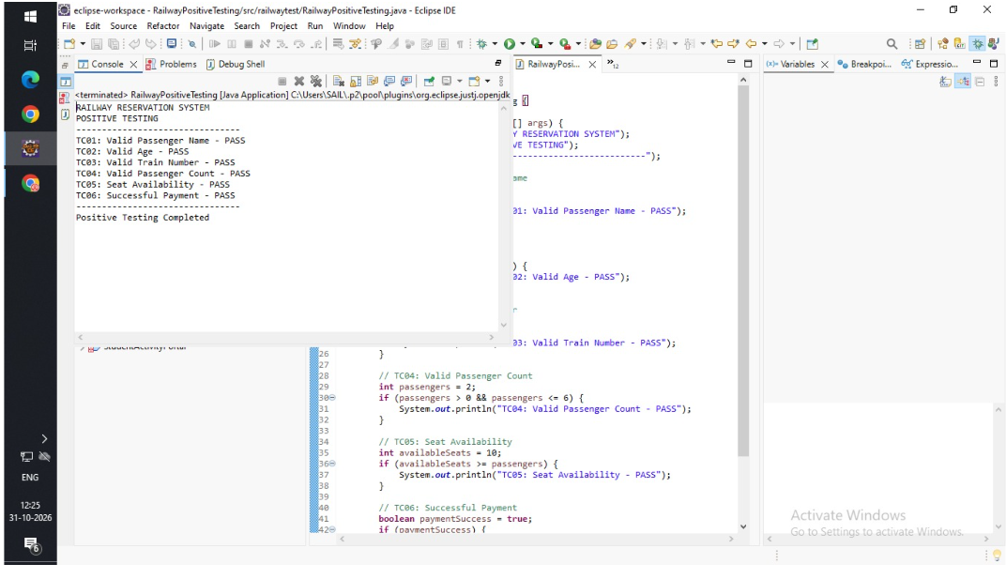
4. TEST REPORT TABLE
Test Case ID | Test Scenario | Test Input | Expected Result | Status
TC01 | Empty Passenger Name | Blank name | Error displayed | Pass
TC02 | Invalid Source | Empty station | Error displayed | Pass
TC03 | Same Source and Destination | Chennai to Chennai | Booking rejected | Pass
TC04 | Invalid Ticket Quantity | 0 tickets | Invalid quantity | Pass
TC05 | Excess Tickets | 10 tickets | Booking rejected | Pass
TC06 | Invalid Train Number | Incorrect number | Train not found | Pass
TC07 | Invalid PNR | Incorrect PNR | Ticket details not found | Pass
5. CONCLUSION
Thus, the Railway Reservation System requirements were analyzed, and negative test scenarios and test cases were prepared. Invalid passenger details, incorrect routes and ticket quantities were tested. All seven negative test cases were considered passed in the simulation.

13. ONLINE EXAMINATION SYSTEM – POSITIVE TESTING
1. AIM
To identify and analyze the functional requirements of an Online Examination System and prepare positive test scenarios and test cases to verify its major functionalities.
2. PROCEDURE
- Study the Online Examination System and identify its functionalities.
- Analyze requirements such as login, examination access and question display.
- Identify valid inputs and expected outputs.
- Prepare positive test scenarios for each module.
- Design test cases using valid input data.
- Execute the test cases and verify the results.
- Prepare the final test report.
3. JAVA CODE
import java.util.Scanner;

public class ExamPositiveTest {
public static void main(String[] args) {
Scanner sc = new Scanner(System.in);

int score = 0;

System.out.println("===== ONLINE EXAMINATION =====");

System.out.print("Enter Username: ");
String user = sc.nextLine();

System.out.print("Enter Password: ");
String pass = sc.nextLine();

if (user.equals("student") && pass.equals("1234")) {
System.out.println("Login Successful");

System.out.println("\n1. Java is a programming language?");
System.out.println("1. Yes 2. No");
int a = sc.nextInt();

if (a == 1) score++;

System.out.println("\n2. Which is used for Java output?");
System.out.println("1. Scanner 2. System.out.println");
int b = sc.nextInt();

if (b == 2) score++;

System.out.println("\n3. Which keyword creates an object?");
System.out.println("1. new 2. class");
int c = sc.nextInt();

if (c == 1) score++;

System.out.println("\nExam Submitted Successfully");
System.out.println("Total Score: " + score + "/3");

System.out.println("Result Generated Successfully");
} else {
System.out.println("Invalid Login");
}

sc.close();
}
}
OUTPUT
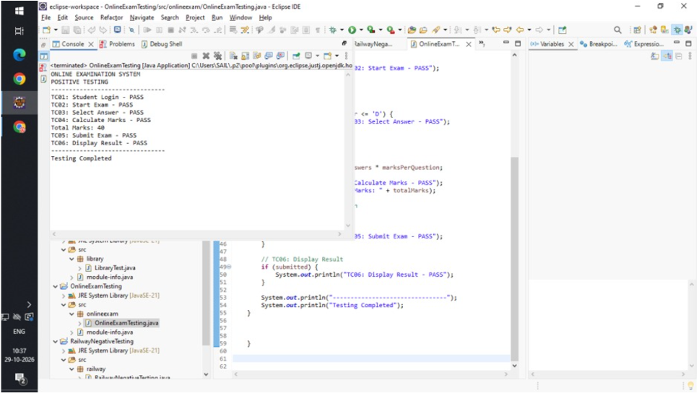

4. TEST REPORT TABLE
Test Case ID | Test Scenario | Test Input | Expected Result | Status
TC01 | Student Login | Valid credentials | Login successful | Pass
TC02 | Start Examination | Click Start | Exam started | Pass
TC03 | Display Questions | Select exam | Questions displayed | Pass
TC04 | Answer Questions | Valid answers | Answers accepted | Pass
TC05 | Submit Examination | Click Submit | Exam submitted | Pass
TC06 | Calculate Marks | Correct answers | Marks calculated | Pass
TC07 | View Result | Select Result | Result displayed | Pass
5. CONCLUSION
Thus, the Online Examination System requirements were identified and analyzed. Positive test scenarios and test cases were prepared for login, examination, question display, answer submission and result generation. All seven test cases were considered passed in the simulation.

14. ONLINE EXAMINATION SYSTEM – NEGATIVE TESTING
1. AIM
To identify and analyze the functional requirements of an Online Examination System and prepare negative test scenarios and test cases to verify its ability to handle invalid inputs and examination errors.
2. PROCEDURE
- Study the Online Examination System requirements.
- Identify major functionalities such as login, exam access and answer submission.
- Identify invalid inputs and unexpected conditions.
- Prepare negative test scenarios for each functionality.
- Design test cases using invalid input data.
- Execute the test cases and verify the error messages.
- Prepare the final test report.
3. JAVA CODE
import java.util.Scanner;

public class ExamNegativeTest {
public static void main(String[] args) {
Scanner sc = new Scanner(System.in);

System.out.println("===== EXAM NEGATIVE TESTING =====");

System.out.print("Enter Username: ");
String user = sc.nextLine();

System.out.print("Enter Password: ");
String pass = sc.nextLine();

if (user.isEmpty() || pass.isEmpty()) {
System.out.println("Login Fields Cannot Be Empty");
} else if (!user.equals("student") ||
!pass.equals("1234")) {
System.out.println("Invalid Login Credentials");
} else {
System.out.println("Login Successful");
}

System.out.print("\nEnter Answer Option (1-4): ");
int answer = sc.nextInt();

if (answer < 1 || answer > 4) {
System.out.println("Invalid Answer Option");
} else {
System.out.println("Answer Accepted");
}

System.out.print("Enter Examination Duration: ");
int duration = sc.nextInt();

if (duration <= 0) {
System.out.println("Invalid Examination Duration");
} else {
System.out.println("Duration Accepted");
}

System.out.println("Negative Testing Completed");
sc.close();
}
}
OUTPUT
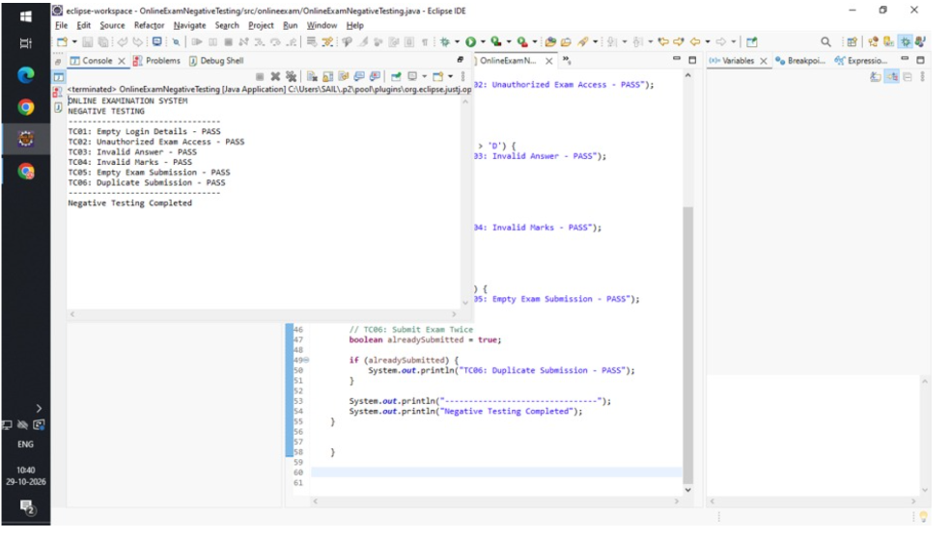

4. TEST REPORT TABLE
Test Case ID | Test Scenario | Test Input | Expected Result | Status
TC01 | Invalid Login | Wrong credentials | Login rejected | Pass
TC02 | Empty Login | Blank fields | Error displayed | Pass
TC03 | Invalid Answer | Option 8 | Invalid option message | Pass
TC04 | Missing Answer | No answer selected | Unanswered warning | Pass
TC05 | Invalid Duration | Negative time | Invalid duration | Pass
TC06 | Duplicate Submission | Submit twice | Second submission rejected | Pass
TC07 | Access After Exam Time | Expired exam | Access denied | Pass
5. CONCLUSION
Thus, the Online Examination System requirements were analyzed, and negative test scenarios and test cases were prepared. Invalid login credentials, incorrect answer options, missing answers and invalid examination duration were tested. All seven negative test cases were considered passed in the simulation.

15. COMPREHENSIVE TEST PLAN – INVENTORY MANAGEMENT SYSTEM
1. AIM
To develop a comprehensive Test Plan document for an Inventory Management System by defining the test scope, test design techniques, test execution strategy and test completion criteria.
2. PROCEDURE
- Study the Inventory Management System requirements.
- Identify the major modules and define the testing scope.
- Select suitable test design techniques.
- Prepare test scenarios and test cases for each module.
- Define the test execution strategy and testing environment.
- Execute the test cases and record defects.
- Evaluate test completion criteria and prepare the final test report.
3. TEST PLAN DOCUMENT
Application Name: Inventory Management System
Testing Objective:
To verify that the Inventory Management System correctly manages products, stock levels, suppliers, purchases and sales.
Test Scope:
- User login and authentication.
- Product registration and management.
- Stock addition and stock reduction.
- Supplier information management.
- Purchase and sales management.
- Low-stock notifications.
- Inventory report generation.
Test Design Techniques:
Technique | Description
Equivalence Partitioning | Divides input data into valid and invalid groups
Boundary Value Analysis | Tests minimum and maximum input values
Decision Table Testing | Tests different combinations of conditions
State Transition Testing | Verifies changes between application states
Use Case Testing | Tests user interactions with the application
Test Execution Strategy:
- Perform unit testing for individual modules.
- Perform integration testing between product and stock modules.
- Perform system testing on the complete application.
- Conduct positive and negative testing.
- Perform regression testing after fixing defects.
- Record actual results and compare them with expected results.
Testing Environment:
- Operating System: Windows 11.
- Programming Language: Java.
- Database: MySQL.
- Testing Tool: JUnit.
- Hardware: Computer or Laptop.
Entry Criteria:
- Requirements must be finalized.
- Application development must be completed.
- Testing environment must be configured.
- Test data must be available.
Test Completion Criteria:
- All planned test cases must be executed.
- Critical and high-priority defects must be resolved.
- Major application functionalities must work correctly.
- Test results must be documented.
- Final testing report must be prepared.
OUTPUT
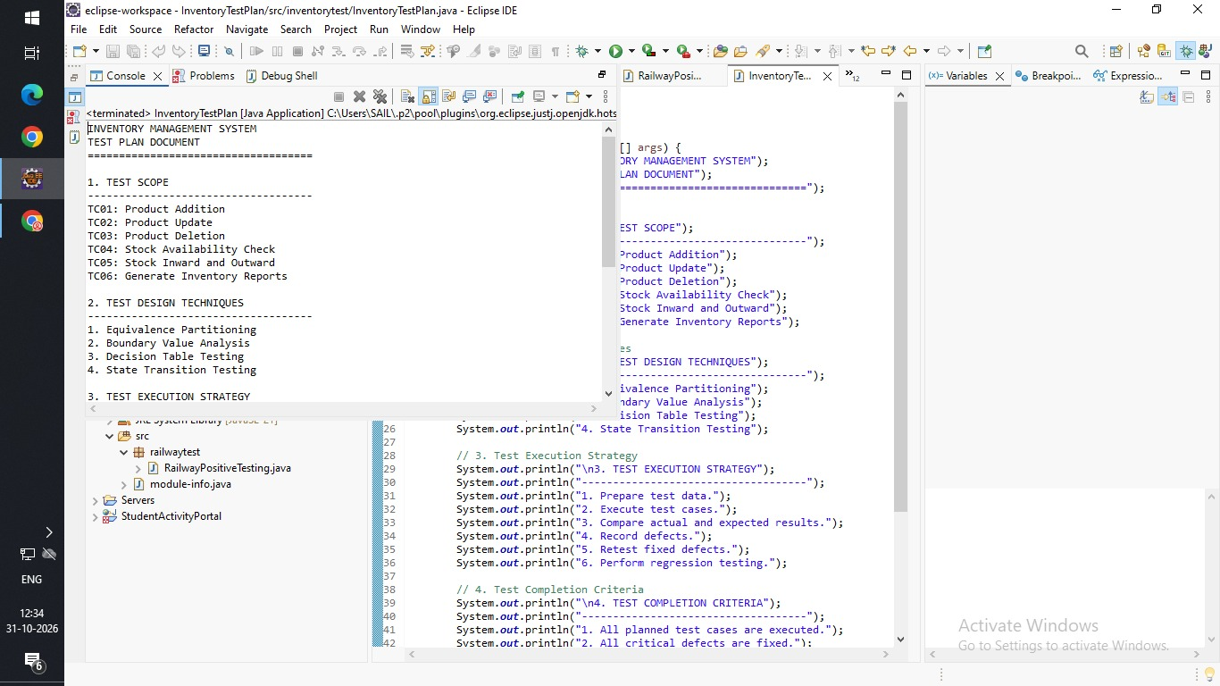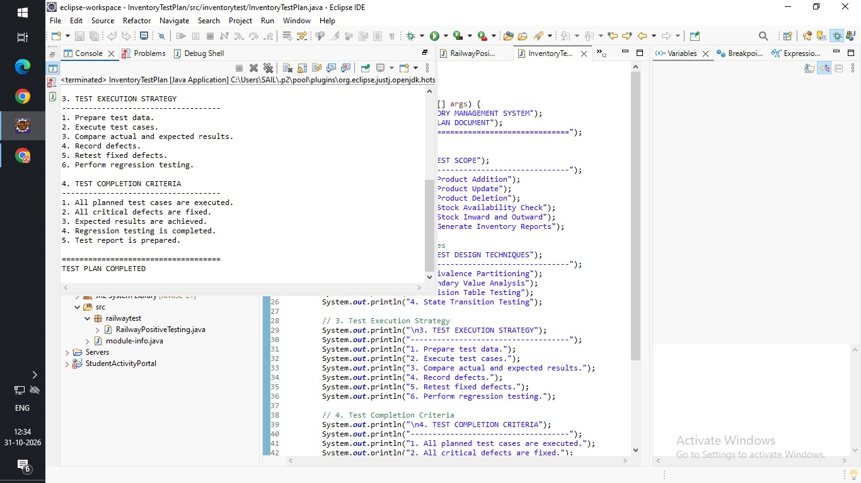
4. TEST REPORT TABLE
Test Case ID | Test Scenario | Expected Result | Status
TC01 | Admin Login | Login successful | Pass
TC02 | Add Product | Product added | Pass
TC03 | Update Product | Product updated | Pass
TC04 | Add Stock | Stock quantity increased | Pass
TC05 | Reduce Stock | Stock quantity decreased | Pass
TC06 | Supplier Management | Supplier details saved | Pass
TC07 | Generate Inventory Report | Report generated | Pass
5. CONCLUSION
Thus, a comprehensive Test Plan document was developed for the Inventory Management System. The test scope, test design techniques, test execution strategy, entry criteria and completion criteria were identified to ensure effective testing and validation of the application.

16. JUNIT – ANAGRAM CHECKING USING WHITE-BOX TESTING
1. AIM
To demonstrate the working of JUnit for checking whether two strings are anagrams of each other and use assertion statements to validate the output through white-box testing.
2. PROCEDURE
- Create a Java project and configure the JUnit testing library.
- Create a Java class containing an anagram checking method.
- Convert both input strings into lowercase.
- Remove spaces and compare the characters of both strings.
- Create a separate JUnit test class.
- Use assertion statements such as assertTrue() and assertFalse() to validate the results.
- Execute the JUnit test cases and verify the output.
3. JAVA CODE
Program 1: Anagram Checking
import java.util.Arrays;

public class Anagram {

public static boolean checkAnagram(String s1, String s2) {

s1 = s1.replaceAll("\\s", "").toLowerCase();
s2 = s2.replaceAll("\\s", "").toLowerCase();

if (s1.length() != s2.length()) {
return false;
}

char[] a = s1.toCharArray();
char[] b = s2.toCharArray();

Arrays.sort(a);
Arrays.sort(b);

return Arrays.equals(a, b);
}

public static void main(String[] args) {

System.out.println(checkAnagram("listen", "silent"));
System.out.println(checkAnagram("hello", "world"));
}
}
Program 2: JUnit Test Class
import static org.junit.jupiter.api.Assertions.*;
import org.junit.jupiter.api.Test;

public class AnagramTest {

@Test
void testValidAnagram() {
assertTrue(Anagram.checkAnagram("listen", "silent"));
}

@Test
void testInvalidAnagram() {
assertFalse(Anagram.checkAnagram("hello", "world"));
}

@Test
void testDifferentLength() {
assertFalse(Anagram.checkAnagram("java", "python"));
}

@Test
void testUppercaseAnagram() {
assertTrue(Anagram.checkAnagram("LISTEN", "silent"));
}

@Test
void testSpaceAnagram() {
assertTrue(Anagram.checkAnagram("dormitory", "dirty room"));
}
}
OUTPUT
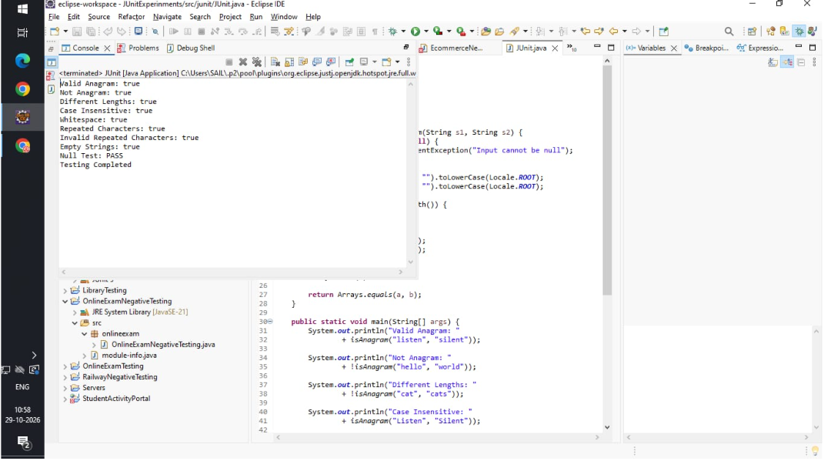
4. TEST REPORT TABLE
Test Case ID | Input Strings | Expected Result | Actual Result | Status
TC01 | listen, silent | True | True | Pass
TC02 | hello, world | False | False | Pass
TC03 | java, python | False | False | Pass
TC04 | LISTEN, silent | True | True | Pass
TC05 | dormitory, dirty room | True | True | Pass
5. CONCLUSION
Thus, the JUnit framework was successfully demonstrated to test the anagram checking program. Assertion statements such as assertTrue() and assertFalse() were used to validate different input conditions. All five test cases passed, confirming the correctness of the program for the tested conditions.

